

**January/February 2020**

Welcome back to a brand new year at Ash Green; we hope you have had an enjoyable Christmas and are looking forward to the New Year!

**Topic**

This half term in topic – particularly History – we will be learning all about the Ancient Egyptians; this topic is new to Year 6 and we are very excited about it. During this unit of work, we will develop our understanding on what was important to Egyptian people, make comparisons between gods and raise questions when confronted with artefacts. This unit builds on and extends prior knowledge of Ancient Egypt taught in Year 4.

We will link elements of Art and Design Technology to the Egyptians when learning how to use pencils and charcoal to draw faces, as well as sculpting using Papier Mache – in the context of designing and making Egyptian masks.

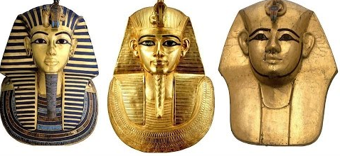

**English**

This half term we will be introducing a brand new text to year 6 - ‘The man who walked between the towers’.  The text is based on a true story about a French man called Philippe Petit, who had an idea to walk between the two towers of the World Trade Centre in New York! Within this unit of work, we will develop our reading skills by considering the author’s purpose, language choices and sentence structures.

The writing opportunities in this unit will include writing a diary entry in the role of Philippe Petit, a balanced argument summing up whether or not Philippe Petit should have carried out the daring act and writing a narrative in the same style as the author.

**Key vocabulary:**

|  |  |  |  |
| --- | --- | --- | --- |
| tightrope | Philippe Petit | equipment | daredevil |
| performance | illegal | memory | capable |

**Maths**

This half term, pupils in Year 6 will be extending their knowledge of the written method of the four operations and applying them to fractions, decimals and percentages. Through this unit, children will be recognising and using fractions of shapes, simplifying fractions using their knowledge of common multiples and comparing and ordering fractions using the Bar Model and a Number Line. They will then look to find decimal and percentage equivalents of fractions, before reading, writing, ordering and comparing decimals to different numbers of decimal places. In order for pupils to develop a deeper understanding of fractions, they will be given daily opportunities to exercise their reasoning and problem solving skills to solve challenges associated with a particular skill.



**Science**

This half term Year 6 pupils will be completing a science topic based on Electricity. We will be looking at identifying common household appliances that run on electricity. This unit builds upon pupils' prior knowledge of Electricity that they began in Year 4 and by the end of the unit they will be able to identify and name components that they include in simple circuits and use circuit symbols to draw accurate circuit diagrams. Children will investigate to discover how to alter circuits to change a lamp's brightness and a buzzer's volume.

**Key vocabulary**

battery       cell        lamp        buzzer         switch     component     series       parallel    appliance

circuit      symbol     brighter   dimmer      complete    incomplete     mains







|  |  |  |
| --- | --- | --- |
| **PE –** Gymnastics and dance | **Music –** Who knows? | **MFL –** Family |
| **PSHE –** How drugs affect us | **ICT –** We are publishers | **RE –** What is compassion? |





Please keep an eye out for a clubs slip coming home with your child on Monday (13th January).

Upper Site

**KS1**

Mrs Cawthra – singing club  
**KS2**  
Mr Wardman – ICT club

Mr Heppenstall – Sports club

Lower Site

**KS1**  
Mrs Rayner – music club  
**KS2**

Miss Hopkins – drawing and colouring club

Miss Bedford – ICT club